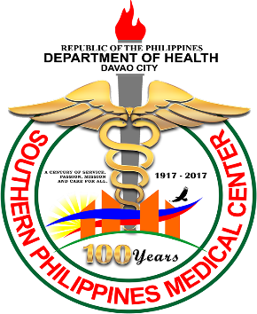

**MEDICAL CERTIFICATE**

This is to certify that Razel Paler, 26 years old Residing at Patin ay Agusan del Sur has been examined in this Hospital as an outpatient on June 5, 2023 with the following finding and diagnosis**.**

**SHORTNESS OF BREATH OR TROUBLE BREATHING, ESPECIALLY WITH PHYSICAL EXERTION.**

**HAS THE SYMPTOMS OF CARDIOMYOPATHY.**